**Git & IntelliJ Assignment**

**Submitted by: Harsh Vardhan Jain**

**Q1) What is the use of the git add command?**

**Soln1:** **git add** command is used to add any new or modified files in the current working directory to the staging area. It helps in preparing the files to be included in the next commit.

**Q2) Write the command to create a branch “feature-group”.**

**Soln2:** The command to create a branch “feature-group” is:

**git checkout -b feature-group**

or

**git branch feature-group**

**Q3) What is a pull request? Write the steps involved in creating a pull request.**

**Soln3:** Pull request is a notification sent by a developer in a repository, asking for the changes that the developer has made in their branch to be merged into the main branch or some other branch. The steps involved in creating a pull request are:

Step 1: The developer writes the code for a new feature/bug fix in a new branch.

Step 2: The developer commits the code to their repository.

Step 3: The developer pushes the code into the central repository.

Step 4: The developer opens a new pull request, from their current branch to the branch into which the code needs to be merged.

Step 5: The developer writes a short description of the changes made and the code altered.

Step 6: The developer self-reviews the pull request once to ensure that there are no mistakes.

Step 7: The pull request is then reviewed by other team members, who might accept it or request changes.

Step 8: If there are any changes, the developer pushes the updated code into the same branch.

Step 9: The pull request is then approved and merged into the required branch.

**Q4) How do you add collaborators?**

**Soln4:** Collaborators can be added to a GitHub repository in the following way:

Step 1: Open the required repository in GitHub

Step 2: Go to the Settings of that repository

Step 3: Go to **Settings 🡪 Access 🡪 Collaborators**

Step 4: Under the **Manage access** section, click on the **Add people** button

Step 5: In the dialog box, we can invite people by their usernames, full names, or emails.

Step 6: The invited people will get an email, and once they approve, they’ll be added as collaborators.

**Q5) What is the command used to commit our changes in github repo?**

**Soln5:** We can use the **git commit -m “sample-message”** command to commit our changes.

For eg: **git commit -m “signup page added”**

**Q6) Create a github account and repository to save all your assignment tasks. Example repository name: rg-assignments**

**Soln6:**

Existing GitHub Account

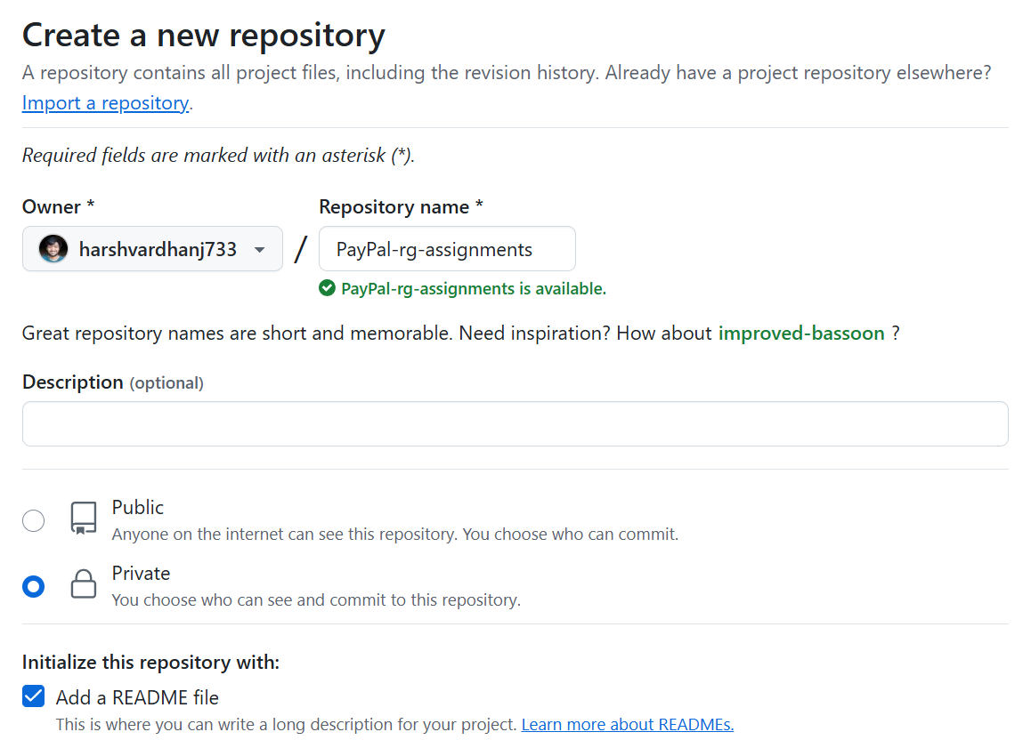

Creating a new private repository named **“PayPal-rg-assignments”**

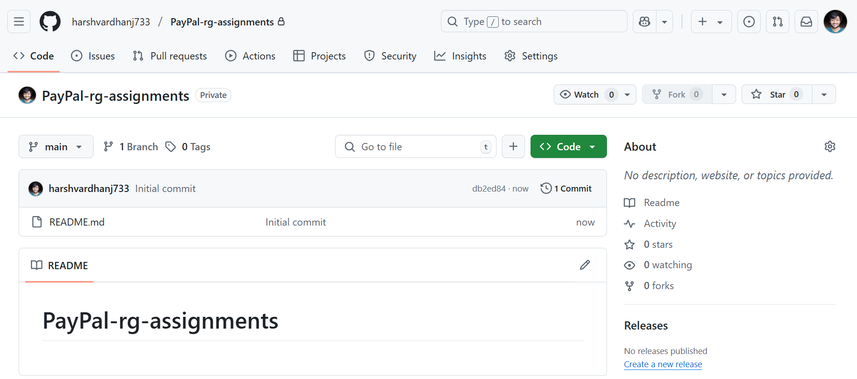

New repository named **“PayPal-rg-assignments”** created

<https://github.com/harshvardhanj733/PayPal-rg-assignments>

**Q7) Create a branch called feature-java(you can use it later to push all your java related tasks to this branch)**

**Soln7:**

Step 1: Clone the repo in local machine

Step 2: Create the **feature-java** branch



Step 3: Add, Commit, and Push changes in the new branch

**Q8) Install IntelliJ IDE. Create a simple java project displaying “Hello World!!”and share the screenshot.**

**

**Q9) In IntelliJ IDE, explore the shortcut keys for the following**

1. **To run the project:** Shift + F10
2. **To select a line:** Ctrl + C
3. **To comment/uncomment a line:** Ctrl + /
4. **To delete a line:** Ctrl + X

******************************************************************************